7) The datas obtained for “5 kph+0° slope”, “10 kph+0° slope”, “5 kph+15° slope” and “10 kph+15° slope” are in the form of excel files, in the submitted file.

9) The obtained responses: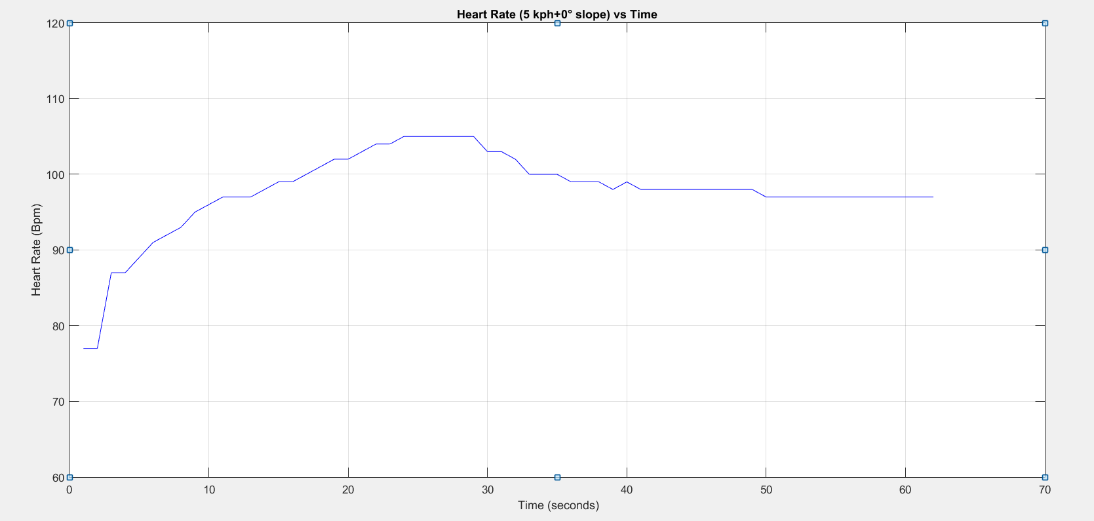

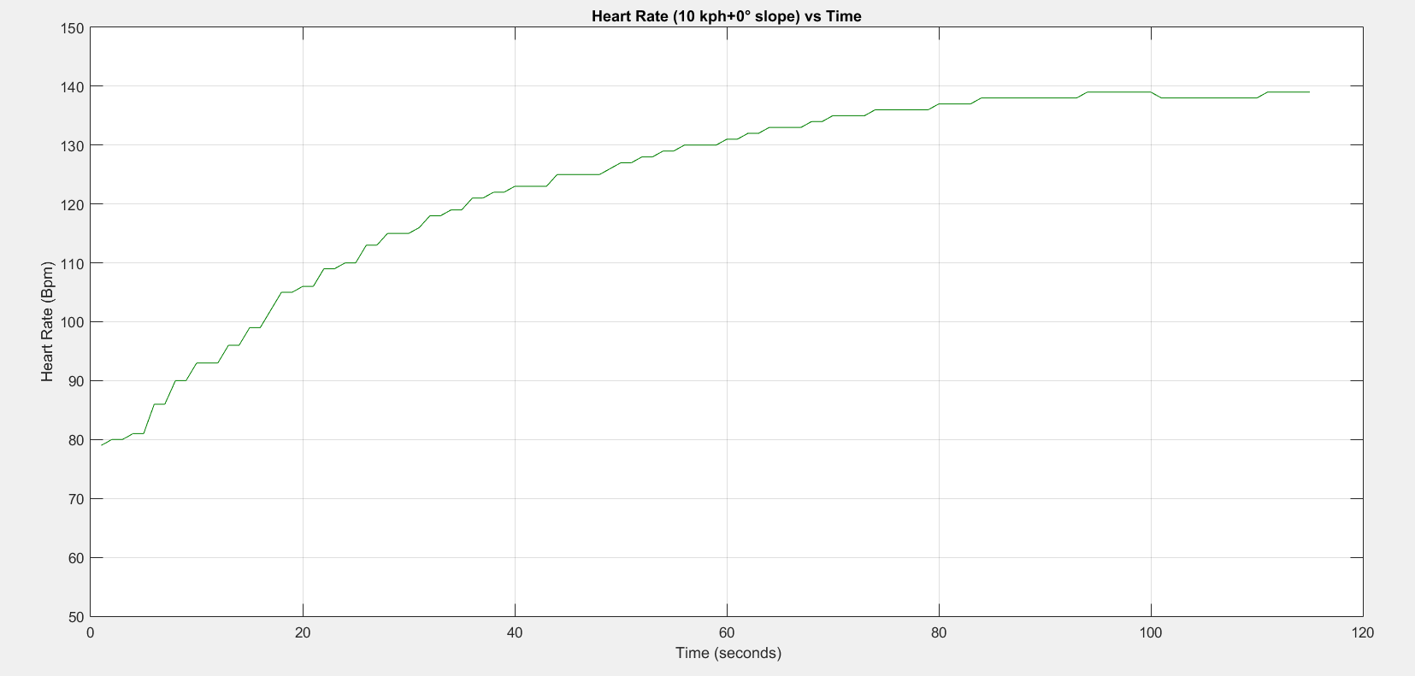

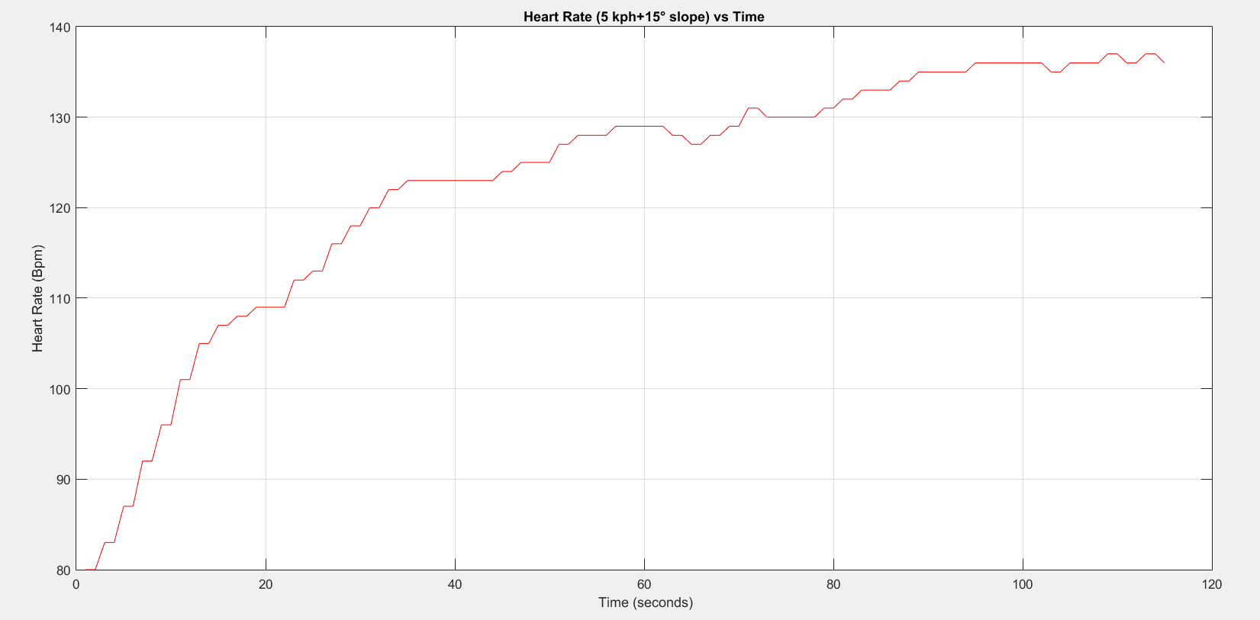

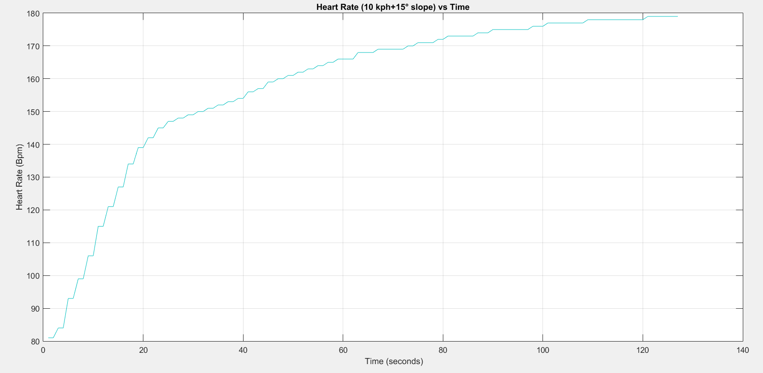

11) The data fitting is done in the same order:

5 kph+0° slope 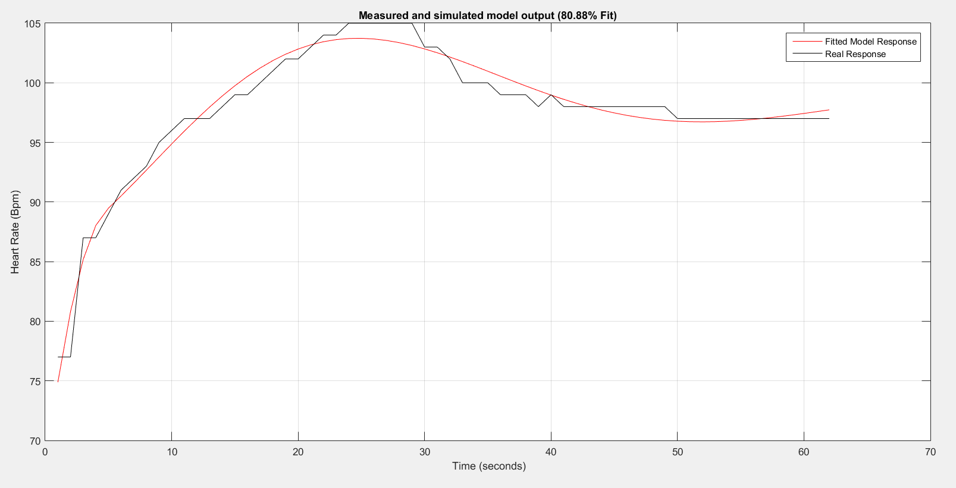case:

10 kph+0° slope case: 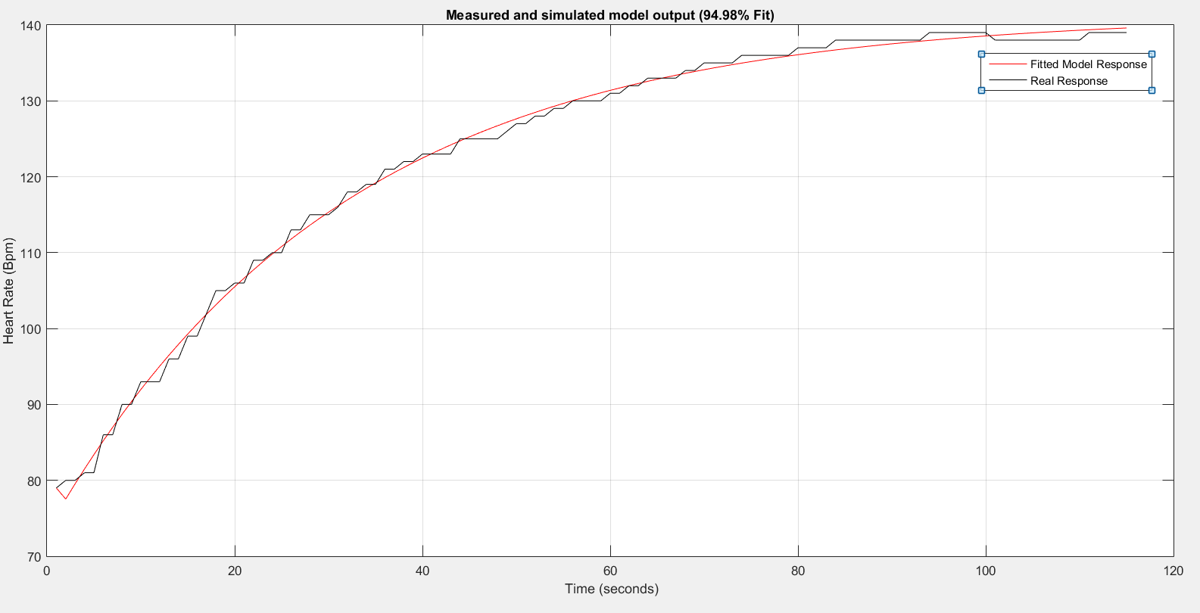

5 kph+15° slope case:

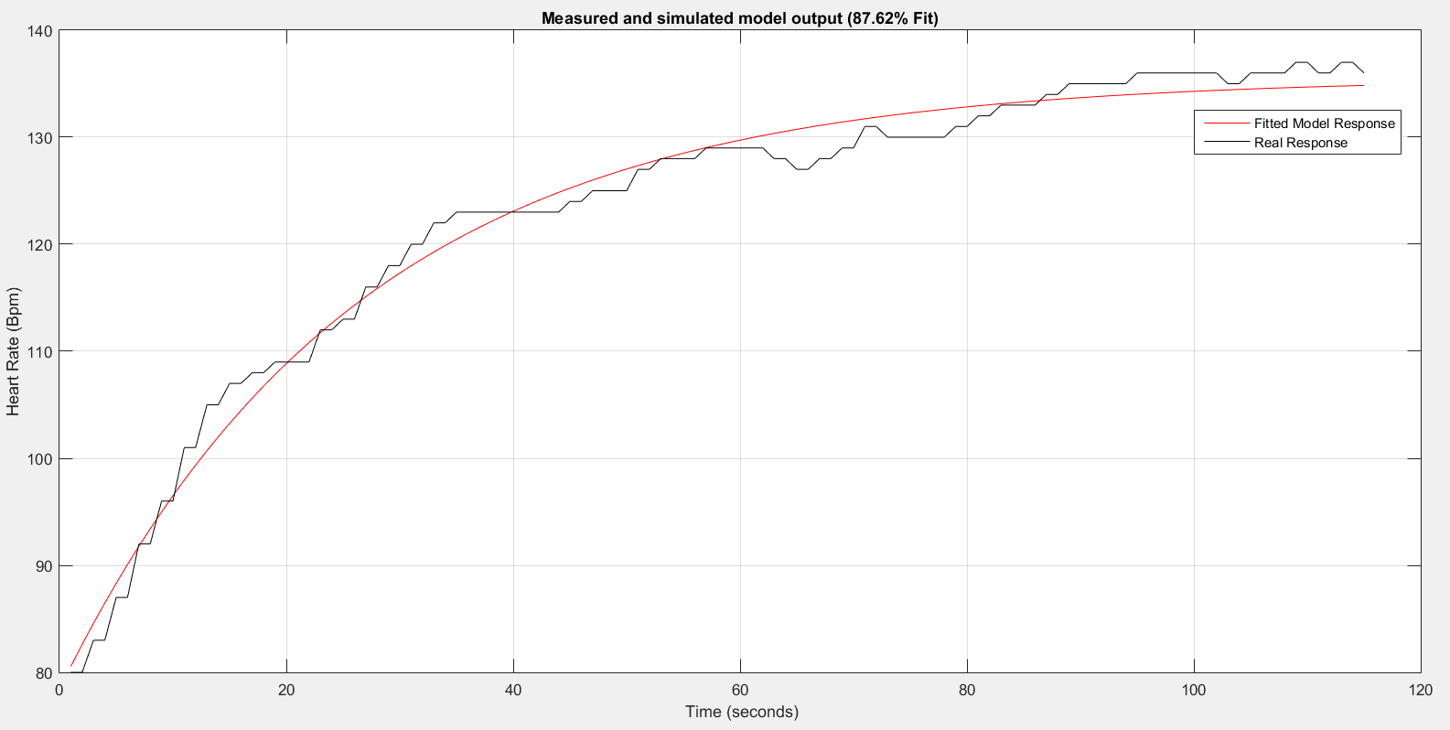

10 kph+15° 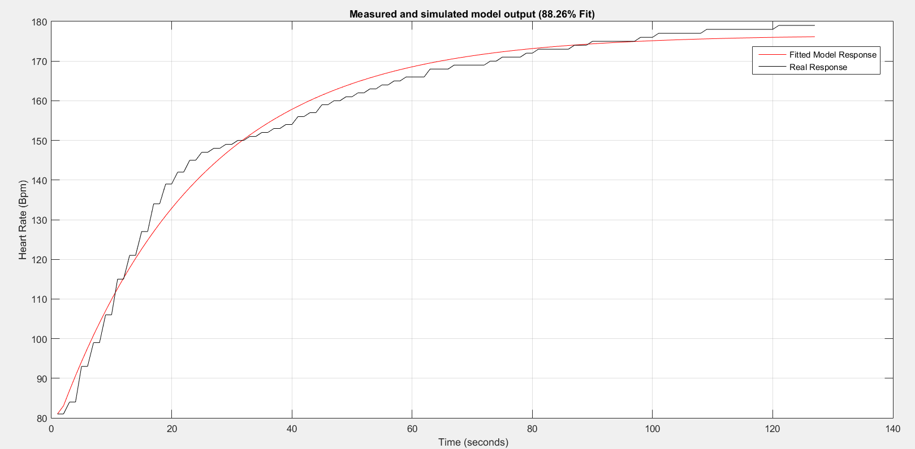case:

12)

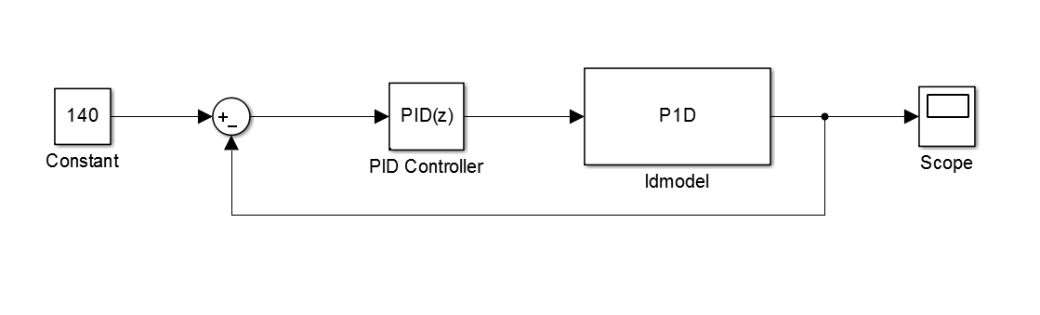

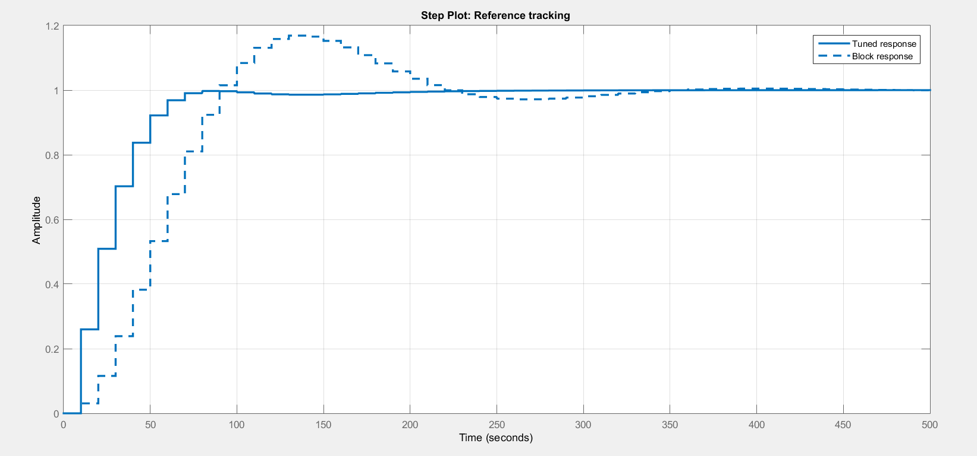13)

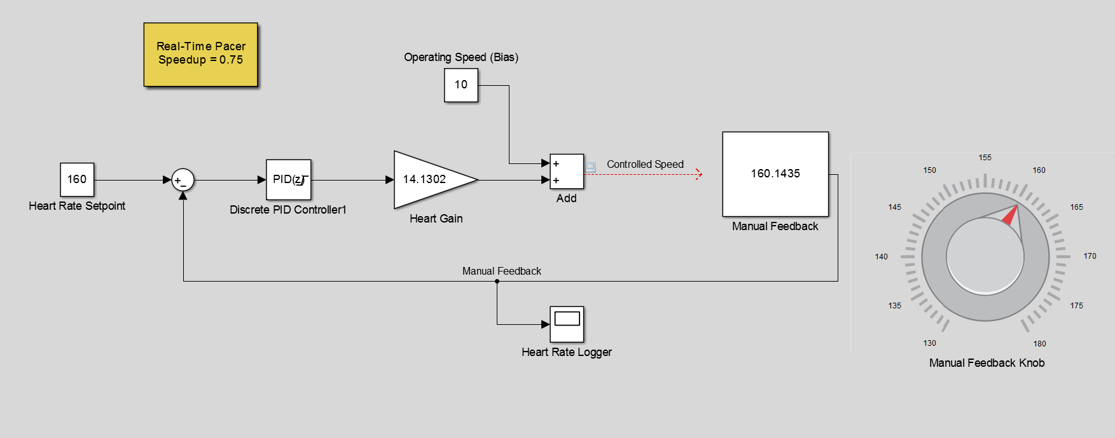14)

DEVAMI VAR